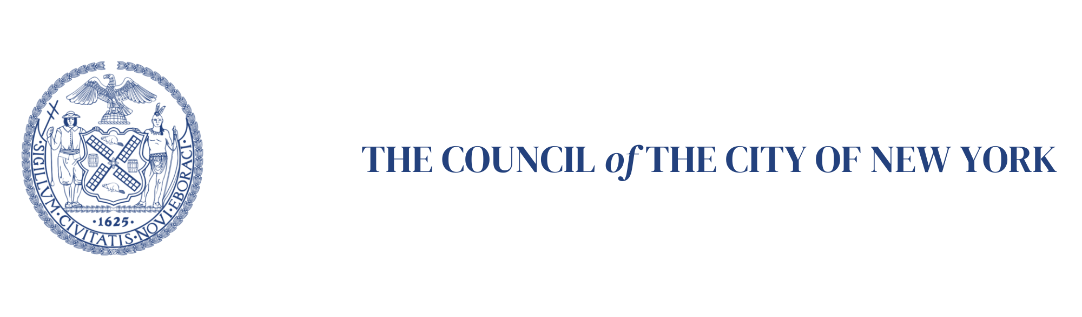
October 10, 2024

Contact:
Edward Amador, Council Member Carlina Rivera, 212-788-7366, eamador@council.nyc.gov
Sam Goldsmith, Council Member Gale Brewer, 212-788-6975, sgoldsmith@council.nyc.gov

Council Members Carlina Rivera and Gale Brewer Join Colleagues and Advocates to Call on City to Implement Legislation Requiring Landlords to Keep Unoccupied Units in Good Repair, Creating Inspection System

City Council Passed Legislation in December 2023 to protect tenants living in buildings with warehoused and vacant units with hazardous conditions

Photos: www.flickr.com/photos/nyccouncil/albums/72177 720321083043

New York, NY- On December 6, New York City Council passed Introduction 0195-2022, now Local Law 1 of 2024, which requires property owners to keep unoccupied units in good repair, creates a 311 reporting option for tenants to report issues in vacant units, and facilitates the inspection of problem vacant apartments to keep them from being a source of potential danger to neighbors.

The purpose of Local Law 1 is to create a system that protects tenants living in buildings with warehoused and vacant units with hazardous conditions. In the middle of a housing crisis, tens of thousands of apartments are reported to be vacant, leaving families without homes and creating unsafe conditions for neighbors. Vacant units may subject surrounding occupants to dangers posed by vermin, fire hazard, garbage accumulation, water leaks, gas leaks, insufficient protection from cold, insufficient protection against fire, and mold. Additionally, when not properly secured against break-in, vacant units may subject occupants to increased likelihood of theft and violent crime.

The Department of Housing Preservation and Development (HPD) was required by law to create a 311 reporting option for tenants to request inspections of unoccupied units whose spillover conditions negatively impact safety and quality of life by August 3, however it has not done so. The Council provided a fiscal impact statement estimating the cost of implementing this policy, and the law was passed and enacted prior to the Fiscal Year 2025 budget. HPD should have been fully aware of the new need, and Council Members Rivera, Brewer, colleagues, and advocates demand that the law is fully implemented as mandated.

“Local Law 1 changes the housing maintenance code to require that landlords keep unoccupied units in good repair, and creates a reporting mechanism that allows the inspection of vacant units that are negatively impacting safety and quality of life. Failure to maintain units, keeping units vacant, and warehousing units is a classic strategy used by landlords to displace people, and up until now the law allowed unscrupulous landlords to use neglected units to their advantage. All New Yorkers deserve healthy homes, and HPD must fully implement Local Law 1 to protect the wellbeing of all New York City tenants,” said Council Member Carlina Rivera (D-02).

“Ensuring that all New Yorkers enjoy safe and sanitary living conditions is of the utmost importance,” said Council Member Gale Brewer (D-06). “For years I’ve heard from enough Manhattanites who live next door to toxic fumes, garbage, and vermin to know that we need action. That’s why we passed a law. And when the New York City Council passes a law, it has to be implemented.”

“Far too many of our neighbors live in unsafe conditions, and far too many of our neighbors cannot find quality housing. Local Law 1 of 2024, of which I was a proud co-sponsor, tackles these issues. The legislation establishes important agency oversight for unoccupied units — making it easier for New Yorkers to ultimately access them, and to keep current tenants safer in their homes. It gives residents a new 311 reporting option when vacant apartments cause problems in their buildings. I join my colleagues in calling on the Department of Housing Preservation and Development to meet its obligation to create a 311 reporting option for tenants to request inspections of unoccupied units creating spillover conditions and negatively impacting safety and quality of life, as required by statute,” said Council Member Pierina Sanchez, Chair of the Committee on Housing and Buildings.

“Local Law 1 protects the health of New Yorkers living near vacant units in hazardous conditions caused by neglectful landlords,” said Council Member Shahana Hanif (D-39). “It’s crucial that the Mayor and HPD act swiftly and fully implement this law to safeguard our communities from the dangers of unmaintained properties.”

“Every New Yorker deserves a safe place to live. Yet the Department of Housing Preservation and Development (HPD) is neglecting their responsibility to provide a mechanism for tenants to report neglected, vacant units which is worsening our housing crisis and making our neighbors less safe. I stand with my colleagues in calling for HPD to fully implement Local Law 1,” said Council Member Tiffany Cabán (D-22).

"This law requiring inspection of vacant apartments will improve the health and safety of tenants in buildings with warehoused apartments since these long-vacant units can contain vermin, garbage, water and gas leaks and mold. We're glad the City Council enacted this law that will enable tenants to report unsafe situations created by negligent landlords" said Steve Herrick, Executive Director of Cooper Square Committee.

"Local Law 1 was passed because too many tenants were living near vacant apartments in deteriorating conditions. Despite the August 3rd effective date, the law is still not implemented. The longer this plays out, more tenants will continue to be exposed to toxic mold, rats, and other harmful materials these vacant units contain. I urge HPD and the Adams administration to implement Local Law 1 immediately. The health and well-being of these tenants are at stake," said Nick E. Smith, Executive Director, Communities Resist.

